********



**Saturday 11th June 2016**

**Queen Elizabeth Olympic Park**



**As well as the British Sprint Championships, this event is a round of the UK Orienteering League.**

**Event Programme/Final Details**

**Welcome**

On behalf of South East Orienteering Association, Chigwell and Epping Forest Orienteering Club welcomes you to the British Sprint Championships on Queen Elizabeth Olympic Park in London’s East End.

**Please read this Event Programme thoroughly. Important detail is contained throughout and will aid your enjoyment of the Event itself and avoid possible disqualification for non-compliance.**

*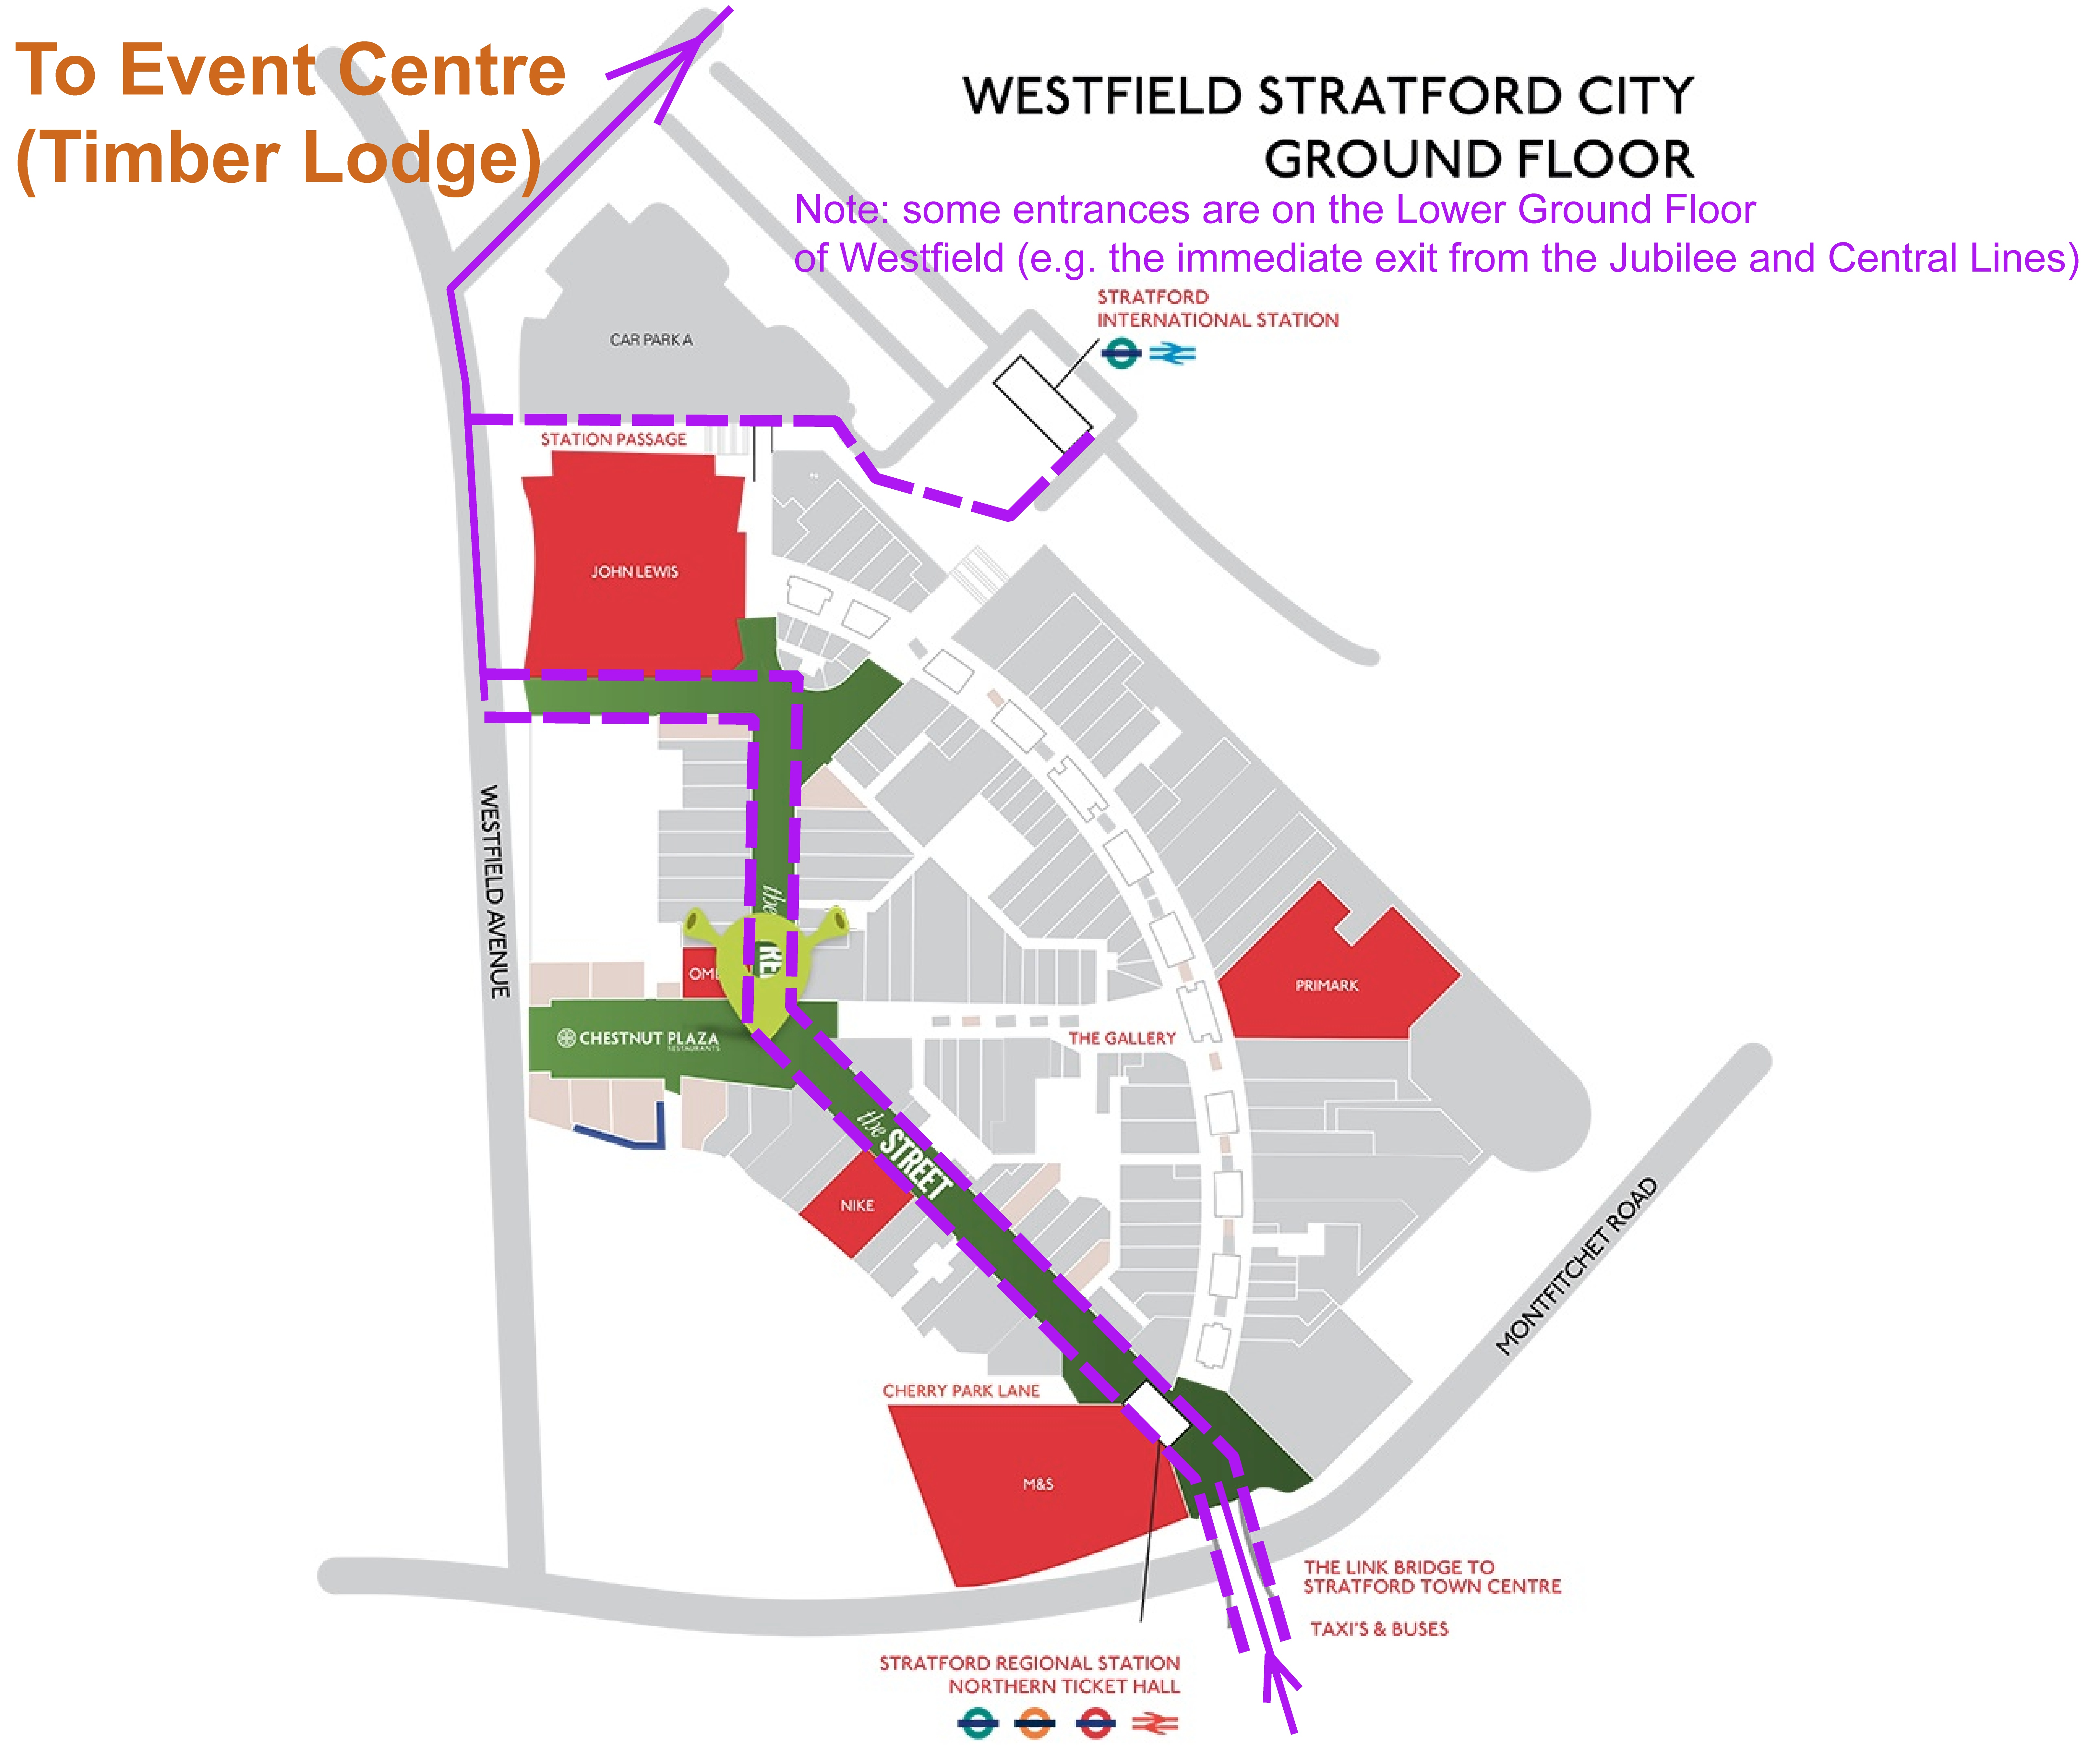***Directions Map**

**Directions**

Please follow these directions to the Event Centre closely; using any other route could risk disqualification by entering the competition area which, it should be noted, is not solely within the Park itself.

In line with Queen Elizabeth Olympic Park policy, car parking is not offered for this event. Directions are therefore shown from the Stratford major transport hub and the immediately adjacent Westfield Shopping Centre.

**Routes to Event Centre**

**From Stratford Station** (Central line, Jubilee line, Docklands Light Railway (DLR), Abellio main line rail services, London Overground services, bus routes), follow the official signs to Queen Elizabeth Olympic Park. Within the station concourses these are yellow and black signs. Outside and through Westfield Shopping Centre at Ground Floor level, follow purple finger posts with a pink cap, along The Street to Westfield Avenue. Then follow Orienteering signs and taped route, using pedestrian road crossings as indicated, to the Event Centre at Timber Lodge, E20 1DY. Allow 20 minutes’ walk, distance 1.1km.

Note some station exits may appear to be at a ground floor level but are in fact at the Lower Ground Floor of Westfield Shopping Centre.

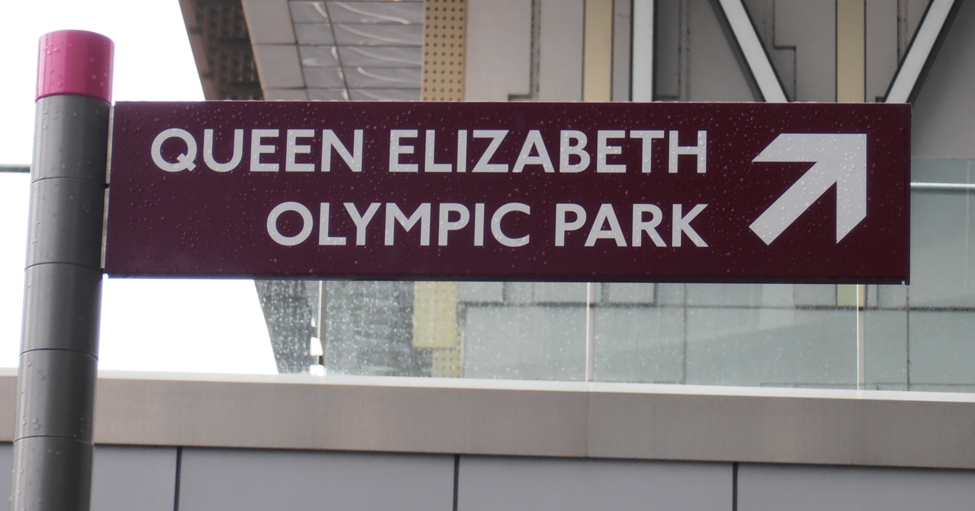

**From Stratford International Station High Speed Rail Services**, turn **right** on exiting ticket barriers and follow official signs as above to Queen Elizabeth Olympic Park to Westfield Avenue, and then follow signed and taped route as above. Allow 20 minutes’ walk, distance 1.0km.

**If using DLR**, alight at Stratford Station not Stratford International terminus – it’s quicker.

Do **not** use Hackney Wick (London Overground Station) or any station other than the Stratford stations as your means of approach to the Park.

Link to “Transport for London”: <https://tfl.gov.uk>

There is no public on-street parking, free or otherwise, in the vicinity of Timber Lodge.

**Important General and Safety Comments concerning the Park and its environs**

The Park is a very popular area with the general public, both as pedestrians and cyclists.

* It can be very busy in certain locations and especially on hot summer days;
* Be attentive to all park users, remembering that some may be preoccupied with other interests or activities;
* Be attentive if passing children’s play areas;
* Avoid blocking any pathways when congregating for the starts;
* Be wary of queues for any of the Park’s activities;
* Recognise that the Park has deep, wide, uncrossable rivers and canals;
* There will be another major event taking place on the same day which will create additional pedestrian footfall through the Event Centre area in the early afternoon.

**Event Centre Map**

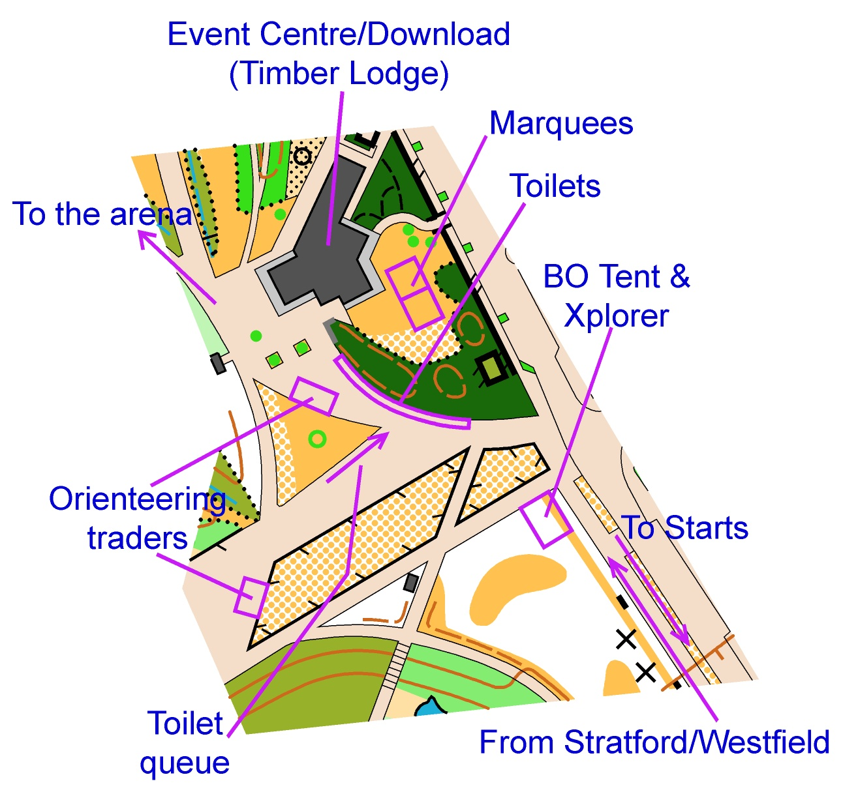

**Event Centre**

The Event Centre is at Timber Lodge Conference Suite and its environs. It includes:

* Enquiries and general information
* Race bib issue
* Hired SI-card collection
* Start Lists
* Download
* Middle Distance queries and enquiries
* Trophy Return
* Massage

The Conference Suite has a hard-wearing floor, but please avoid bringing into the suite any dirt or detritus on your shoes.

Timber Lodge environs

* Competitor changing and clothing depository
* Toilets
* Results
* First Aid
* Orienteering traders
* British Orienteering stand and Xplorer

There are no Entry On The Day or Colour Coded courses.

It has not been possible to provide a model area.

**Timetable**

09:00 Event Centre opens

10:25 Heats – commence

11:35 Heats – last starter

12:00 Heats – courses close

12:05 Heats – download closes

13:30 Finals – commence

15:10 Finals – last starter

15:30 Finals – courses close

15:35 Finals download closes

16:00 Medal Ceremony

17:00 Event closes

**Event Arena**

The Event Arena is close to Timber Lodge and will be used for the Finish of both the Heats and the Finals.

The Park comprises recovered industrial wasteland with irrigation systems close to the surface in many areas, and as such it will not be possible to permit large tents which require pegging or staking, nor feather flags which require staking. Beach shelter pop-up tents are acceptable, but space is limited and pitches may have to be changed between the Heats and Finals. The Park can also be very windy on occasions; pop-up tents need to have sufficient weight internally to avoid being blown away. Please contact the Organiser if you require any further guidance.

Please allow for a walkway in front of tents for spectator movement. There is some permanent exposed tiered seating in the Event Arena.

* **Commentary**

Commentary in the Event Arena will be provided by Chris Poole and Andy Monro, with technical support from GP Projects.

**Race Bibs**

Race bibs must be worn, unfolded and visible, on the chest by all competitors in both the Heats and the Finals. Competitors who fail to comply or are wearing the wrong number will be unable to start. Safety pins will be provided at the Event Centre.

Bib numbers will correspond with the **race numbers** shown on Fabian4, including Men and Women’s Open Heats. A list of bib numbers will be available for reference in the Event Centre.

When collected please complete your details on the reverse of bib. Any competitor with a known **medical condition** that could give rise to a safety risk is strongly advised to complete the medical information on the back of their race number bib.

Those who qualify for the **Open Class A Finals only** are to collect fresh bibs from Enquiries as soon as the Finals Start Lists are published. These will be in reverse numerical order (the lowest starting last).

**Electronic Punching**

SI punching will be used. Hired SI cards will be available at the Event Centre and must be returned at download after their use. A charge of £30 will be made for lost or non-returned SI cards.

If an SI unit fails to flash and beep, use the backup pin punch to punch along an edge of the map.

**Start List**

The Start List is now available on [www.fabian4.co.uk](http://www.fabian4.co.uk) and will be displayed at the Event Centre.

**Trophy Return**

These should be brought to Enquiries.

**Massage**

Rachel Collins (DFOK) from Pinnacle-Health is providing a massaging service for this event. Post Sports Massage is great for flushing away any toxins after racing and realigning muscle fibres. Whether you have a specific injury or need general maintenance then come to the Event Centre. Booking-in will be on the day with a timesheet; the price will be £10 for 15 minutes.  If you have any questions prior to the event feel free to email Rachel at [rachel@pinnacle-health.co.uk](mailto:rachel@pinnacle-health.co.uk)

**Competitor Changing and Clothing Depository**

Two marquees sited close to the Event Centre will be available for changing and the deposit of clothing. They will not be segregated into male and female.

The Park is a very public place and we cannot give any guarantees regarding security of personal belongings, therefore these are left at your own risk. We suggest that you travel with the minimum of valuables and due to the high volume of entries we cannot act as a deposit of any items at Enquiries.

**Toilets**

Portaloos (14 plus one accessible) will be provided in the environs of the Event Centre. There will be a designated queuing area to avoid obstructing the walkways which will be in use by the general public. The toilets **within Timber Lodge** itself should **not** be used by competitors or for changing or washing.

When making your way to the Event Centre you may wish to use the toilet facilities within the Westfield Shopping Centre which are numerous and clearly signed.

There will be no additional toilets at the Starts. Please do not relieve yourselves elsewhere in what is a very public environment, either before, during or after running - anyone doing so is liable to be disqualified by the Organiser.

**First Aid**

First Aid, provided by M&M Medical Services, will be present close to the Event Centre.

The nearest A&E is Homerton University Hospital, Homerton Row, E9 6SR, details of which will be held at Enquiries.

**Orienteering Traders**

**Ultrasport** and **CompassPoint** will be present close to the Event Centre.

**Xplorer**

British Orienteering’s tent will be close to the Event Centre and Xplorer will be adjacent to it.

**Safety**

Competitors are responsible for their own personal safety and for assessing their own abilities to complete their chosen course.

Competitors:

* must not run if unwell;
* should ensure that proper preparations are undertaken in the event of adverse weather conditions. NB there is little shade in the Park.
* are strongly advised to complete the reverse side of their race number with contact details and relevant medical information;
* should report any concerns about missing competitors to Enquiries or any Event Official;
* should bring their own water, especially if hot weather is forecast.

**Refreshments**

* Timber Lodge serves food at reasonable prices but may find it very difficult to cater for everyone in the time between the Heats and the Finals <http://queenelizabetholympicpark.co.uk/the-park/attractions/timber-lodge-cafe>
* Westfield Shopping Centre has over 90 food and drink outlets. Competitors should retrace the signed route they took when coming to the Event Centre earlier in the day in order to reach Westfield Shopping Centre. <https://uk.westfield.com/stratfordcity>
* Competitors will be at risk of disqualification if they visit any food outlets or any other attraction within the Park before the courses officially close at 15:30. We rely on your honesty in this matter.

**Dogs**

Queen Elizabeth Olympic Park has the following policy - “Please be aware that dogs are permitted on the Park with a lead”. Owners are required to clear up after their dog. Please note:

* Competitors are not permitted to compete with a dog;
* Start times cannot be adjusted to allow for continued supervision of a dog.

**Rubbish and Litter**

Please take all your rubbish home. No rubbish bins/bags will be provided.

**Water**

Water will **not** be provided at the Finish or on any of the courses.

**Photography**

In accordance with British Orienteering Child Welfare Policy and Procedures, any person wishing to engage in any video, zoom or close range photography should make themselves aware of the above policy. Organisers reserve the right to challenge anyone who is giving cause for concern. If anyone has concerns about inappropriate or intrusive photography they should speak to the Event Organiser or Race Day Organiser. The use of tripods in busy areas is not permitted in the Park.

The Official Photographer for the event is David Hallworth.

Any competitor who does not consent to their photograph(s) being used by British Orienteering in printed publications and websites should email the Organiser directly with their name and bib number in order for any such photographs to be removed or not uploaded in the first instance.

* **Drones**

Queen Elizabeth Olympic Park Policy is as follows: “General use of drones and remote controlled flying models is not permitted on any area of Queen Elizabeth Olympic Park.” Please observe this policy.

**Competitor Clothing**

Full body cover is not mandatory for this event. Shorts and singlets may be worn, but competitors may encounter stinging nettles in certain areas.

**GPS Data Loggers**

British Orienteering rules state that “Competitors are permitted to only use a GPS device to record data for use in post-race analysis.” Anyone found breaking this rule will be disqualified.

**Eligibility**

To be eligible to be a British Champion, an individual competitor must on the day immediately preceding the day of competition in question be a member of British Orienteering and: either be a British citizen; or have been a member of British Orienteering in each of the three membership years preceding the year of the competition.

For Juniors who are not British citizens, the membership criteria will be as specified below:

|  |  |
| --- | --- |
| **Age on 31st Dec in year of competition** | **British Orienteering membership criterion** |
| 10 or under | Member on day before the day of competition |
| 11 | Member on day before the day of competition and in previous year |
| 12 | Member on day before the day of competition and in previous two years |
| 13 and over | As for seniors (above) |

**Qualifying Criteria**

Extract from BO Competition Rule C dated January 2015:

7.4.1 The best competitors from each qualification race heat qualify for the A-final of their class. The next best competitors from each qualification race heat qualify for the B-final and so on.

7.4.2 If there are 36 or more entrants in a class, the number of qualifiers from each heat to the A-final will be equal and will be calculated so that the total number of qualifiers is 18, or the lowest possible number above 18 (it would be 20 if the need exists to have 4 or 5 heats instead of 3).

7.4.3 If there are from 6 to 35 entrants, the number of qualifiers from each heat to the A-final will be equal. They will be split as equally as possible between an A-final and a B-final, with the A-final having at least half the total number of entrants.

7.4.4 If there are fewer than 6 entrants, then all who successfully complete the qualification race will compete in the A-final. Those who do not successfully complete the qualification race (for example do not start or mispunch) may compete as a first starter in the A final. They will not be placed in the Championships results however (although will be eligible for Ranking points).

7.4.5 If two or more competitors tie for a place in a final, all of them will qualify for that final. This will have the effect of reducing the number of qualifiers from that heat in the next ranked Final down.

7.4.6 An entrant is defined as any competitor who appears on the entry list as published at a pre-announced time, usually the final closing date for entries.

7.4.7 The starting order of the A Final will be the reverse of the positions in the heats so that the best competitors start last. Competitors with the same position in the different parallel heats will start in the sequence of the number of their heat, i.e. third place in heat one starts before third place in heat 2, etc. Ties in a heat will be decided by drawing lots, e.g. if two competitors tie for 4th place in heat 1, a coin could be tossed to determine who has position 4 and who has position 5 in heat 1 for the purposes of this rule.

7.5.4 Competitors who did not successfully complete their qualification heat (for example did not start or mis-punched) will start first in the lowest ranked final for their age class. They will not be placed in the Championships results however (although will be eligible for Ranking points).

**Complaints and protests**

British Orienteering Rules apply. Any Complaint should be made in writing to the Organiser, using the Complaint form provided, and handed in at the Problem Desk in the Download area as soon as possible. The complaint should be made by 12:15 at the latest for Heats and 15:45 at the latest for the Finals.

The Organiser will decide on the outcome and inform the complainant of the result as soon as possible. There is no fee for making a complaint.

If the competitor is not satisfied with the result of the Complaint, a Protest can be made against the Organiser’s decision no later than 15 minutes after that decision has been given to the competitor.

The Protest must be in writing and handed in at the Problem Desk in the Download area. It will immediately be forwarded to the Controller who will discuss it with the Organiser. If the Protest is still not upheld, it will be handled by the Jury, who will communicate their decision to the complainant as soon as possible. There is no fee for making a Protest.

**Terrain (Please** **observe all Out Of Bounds Areas)**

Queen Elizabeth Olympic Park and its surrounds are a relatively flat area of reclaimed industrial land, landscaped for the 2012 Olympic Games. The area includes some of the iconic structures seen in the TV coverage. The maximum height difference is about 20 metres with the lowest point being along the River Lea and the highest point being the hill with the “Olympic Rings” on it. There is an area of reclaimed wetlands and there are numerous bridges, underpasses, overpasses and a river and canal to add a bit more interest.

Out of bounds and uncrossable areas are a feature of the Park and competitors must respect and adhere to the information shown on the map. The ISSOM symbol 527.001 (Olive-green, area with forbidden access) has been used to depict the usual enclosed gardens and private areas PLUS numerous types of flower bed and ornamental gardens.

Some of the flower beds are wild-flower meadows and as such are important habitats within the Park and not to be encroached upon in any way. In some places, where there is a control close to an ornamental garden or wild-flower meadow short lengths of tape/barrier have been placed to remind you not to go out of bounds. These will not extend for the full length of the feature. You are not allowed to cross the out of bounds areas just because the tape has ended. If you are spotted you will be disqualified. This means you are not allowed to cut corners, run across or jump over them (even if you can clear the meadow in one bound). Be aware that the public may decide to have a picnic, take a shortcut or have a lie down in these areas, BUT YOU ARE STILL NOT ALLOWED to cross or encroach upon them in any way.

Should a competitor be identified by the course and control marshals to have crossed any such areas they will be disqualified. Additionally, should the disqualification occur in the Heats, the competitor will not be included in the start list for the Finals, even as non-competitive.

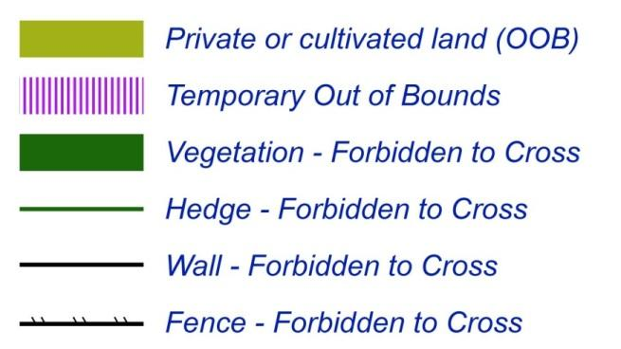**Areas forbidden to access, or features**

**forbidden to cross, penalised by disqualification.**

**Special Symbols used:**

|  |  |  |
| --- | --- | --- |
| **Map Symbol** | **Map Description** | **Explanation** |
|  | Individual tree, trunk >30cm | Single mature tree with a trunk more than 0.3m in diameter |
|  | Small tree/sapling or bush | Mainly saplings |
|  | Bench | A substantial permanent seat/table  Path or Roadside seats or benches are not marked |
|  | Play Equipment | Outdoor Gym station |

**Terrain Dangers**

No holes in the ground have been found that may catch runners by surprise. Small urban furniture (e.g. bicycle racks, electrical boxes) have not been mapped, so keep watching the ground ahead.

There are likely routes in opposite directions around tight building corners so be aware of this. Planning is such that many corners to be negotiated have reasonable visibility but a very small person (orienteer or member of the public) may not be visible and some collisions may be unavoidable if orienteers are inattentive! The Park has very little traffic and most of it is slow moving; in fact the fastest traffic is probably the random cyclists.

There are likely to be lots of members of the public, particularly later in the day, not looking where they are going (texting, taking selfies or photographs, or just wandering about). The Event Centre and Event Arena are on the main route from Westfield Shopping Centre to the Hockey Centre which is hosting a series of tournaments starting on race day, so please be aware as most of the Heats will cross this route at some point.

It is possible that you will encounter unmapped areas of maintenance work during both the Heats and the Finals. These works will normally be barriered and not accessible to the public but occasionally the cleaners, with industrial strength washers, can be spotted washing down footways.

All the Heats courses cross a lightly used road. Heats courses 5 to 8 cross this road diagonally and there is a control for all those courses just before the road. Heats courses 1 to 4 cross the road perpendicularly with a control just before the road. There will be marshals to warn of any oncoming traffic, but it is more likely that you will encounter orienteers in the area rather than vehicular traffic. All courses, both for the Heats and the Finals, will encounter bodies of water, some of it very deep, and you are reminded that blue features bordered or surrounded by a black line ARE NOT TO BE CROSSED. Some of the Finals courses pass close to an intermittent water fountain – the ground in this area can be wet and slippery, and there may be a lot of public close by watching the “display”.

**Control Descriptions**

Loose Control Description sheets (dimensions 55mm width, maximum 175mm length) will be available at the Start at -3 minutes, they will be on waterproof material. IOF Pictorial Control Descriptions will be used for all courses.

**Map and Course Descriptions**

The map scale is 1:4000 and the contour interval is 2.5m. The competition maps have been digitally printed by Hassall and Lucking on waterproof A3 paper. Control descriptions will be on the map as well as loose in the start boxes. Only Control Numbers, not codes, will be shown on the map. The map was surveyed and drawn by Graham Gristwood ([www.ggmaps.co.uk](http://www.ggmaps.co.uk) ) during 2015-2016. Planners’ and controller’s updates were done by Mike Elliot April/May 2016.

**Course Lengths**

Course lengths have been measured along the optimal route and not the straight line, following IOF rather than BO Rules, as this is more meaningful.

**Routes to Starts**

The routes to the Starts will be clearly signed from the Event Centre. Competitors must follow the signs and tapes and respect any OOB competition notices.

**Heats Start** – allow 5 minutes’ walk (300m). Call up at -6 minutes.

**Finals Start** – allow 15 minutes’ walk (700m), including controlled road crossings. Call up at -5 minutes.

**Start Procedure**



Number bibs are to be worn by all competitors unfolded and visible as Call-Up will be by Bib number (see separate section Race Bibs on Page 6). There is one Start for the Heats and a different Start for the Finals – make sure you arrive at each in good time for the call-up of your Start Time. SI Clear units will be available outside the entrance to the Start system – please ensure that you have cleared your SI-card before your Call-up.

Please note from the above Start diagram that Call-up for the Heats is at -6 minutes as there is an extra step in their process. Competitors will not know which Heat they are in until they arrive in the -5 minutes Start Box and are called into one of the 3 lanes.

Maps will be presented to competitors in boxes on tables. On entering the -1 minute Start Box, competitors should stand beside the map box for their course. With 10 seconds to go, they will be instructed to pick up their map, check it is the correct course and go on the long (i.e. last) beep from the start clock.

**Late Starters**

Competitors who are late for the call-up of their allocated Start Time should report to the Late Start officials on the right hand side of the Start Area. They will be passed through the start procedure as swiftly as possible and will be allowed to start at their allocated Start Time, if possible without interfering with other competitors. Otherwise, they will be allowed to start at the next available 30 second slot, without interfering with other competitors. At all times, please obey the instructions of the Late Start officials.

If it has not been possible to start a competitor at their allocated Start Time, their actual start time will be recorded by punching start in case a complaint by the competitor is upheld by the Organiser or, if protested, Race Jury; until then their race time will have started at their allocated Start Time. No start times can be changed at the Start and no discussions should be had with Start Officials as to the reasons for a competitor being late. If a competitor believes that the Organiser is to blame for their being late, that discussion should be had at Download at the Problem Desk.

**Heats Course Details**

Maps will be in boxes face down. Competitors will be permitted to pick up their map at -10 seconds to check they have the correct course.

|  |  |  |  |  |  |  |
| --- | --- | --- | --- | --- | --- | --- |
| **Heat courses will close at 12:00. All are to have downloaded by 12:05 to qualify for Finals.** | | | | | | |
| **Classes:** | | **Course:** | **Length (km):** | **Height Climb (m):** | **No of Controls:** | |
| **Men** | **Women** |  | |
| Men Open |  | **1.1** | 3.6 | 50 | 22 | |
| **1.2** | 3.8 | 40 | 22 | |
| **1.3** | 3.8 | 40 | 22 | |
| M16, M35, M40, M45 |  | **2.1** | 3.3 | 30 | 21 | |
| **2.2** | 3.4 | 30 | 22 | |
| **2.3** | 3.3 | 30 | 20 | |
| M50 | Women Open | **3.1** | 3.2 | 30 | 19 | |
| **3.2** | 3.2 | 30 | 18 | |
| **3.3** | 3.3 | 30 | 20 | |
| M14, M55 | W16, W35, W40 | **4.1** | 2.9 | 25 | 18 | |
| **4.2** | 3.0 | 30 | 20 | |
| **4.3** | 3.0 | 30 | 19 | |
| M60 | W45, W50 | **5.1** | 2.7 | 10 | 17 | |
| **5.2** | 2.6 | 20 | 20 | |
| **5.3** | 2.6 | 10 | 18 | |
| M12, M65, M70 | W14, W55 | **6.1** | 2.4 | 15 | 16 | |
| **6.2** | 2.4 | 15 | 18 | |
| **6.3** | 2.5 | 15 | 18 | |
| M75, M80+ | W12, W60, W65, W70, W75, W80+ | **7.1** | 2.2 | 10 | 16 | |
| **7.2** | 2.3 | 20 | 16 | |
| M10 | W10 | **8.1** | 1.8 | 10 | 23 | |

Course lengths in the above table are the “optimum” route and climb has been measured along it.

**Finals Course Details**

Maps will be in boxes face down. Competitors will be permitted to pick up their map at -10 seconds to check they have the correct course.

|  |  |  |  |  |  |  |
| --- | --- | --- | --- | --- | --- | --- |
| **Final courses will close at 15:30. All are to have downloaded by 15:35.** | | | | | | |
| **Classes:** | | **Course:** | **Length (km):** | **Height Climb (m):** | **No of Controls:** |
| **Men** | **Women** |  |
|  |  | **1A** | 3.7 | 85 | 25 |
| Men Open |  | **1B** | 3.5 | 70 | 22 |
|  |  | **1C** | 2.9 | 55 | 19 |
|  |  | **2A** | 3.4 | 75 | 25 |
| M16, M35, M40, M45 |  | **2B** | 3.1 | 60 | 20 |
|  |  | **2C** | 2.7 | 40 | 19 |
|  |  | **3A** | 3.3 | 75 | 23 |
| M50 | Women Open | **3B** | 2.8 | 45 | 18 |
|  |  | **3C** | 2.6 | 45 | 18 |
|  |  | **4A** | 3.1 | 65 | 19 |
| M14, M55 | W16, W35, W40 | **4B** | 2.7 | 45 | 17 |
|  |  | **4C** | 2.1 | 30 | 17 |
|  |  | **5A** | 2.8 | 55 | 19 |
| M60 | W45, W50 | **5B** | 2.4 | 30 | 16 |
|  |  | **5C** | 2.0 | 25 | 15 |
|  |  | **6A** | 2.5 | 45 | 16 |
| M12, M65, M70 | W14, W55 | **6B** | 2.2 | 30 | 14 |
|  |  | **6C** | 1.8 | 15 | 16 |
| M75, M80+ | W12, W60, W65, W70, W75, | **7A** | 2.0 | 35 | 16 |
|  | W80+ | **7B** | 1.7 | 15 | 15 |
| M10 | W10 | **8A** | 1.7 | 25 | 16 |

Should the Finals be delayed for any reason the course closing time of 15:30 will be changed as a result and the revised time announced to competitors, including within the Start lanes.

**Heat Start Times**

Start times for the Heats are available on [www.fabian4.co.uk](http://www.fabian4.co.uk) (posted 30/05). They have been allocated based on the BOF Ranking List and will not be changed. A diagrammatic representation of the Start Time ranges for each Class between 10:25 and 11:35 is:

|  |  |  |  |  |  |  |  |  |  |  |  |  |  |  |
| --- | --- | --- | --- | --- | --- | --- | --- | --- | --- | --- | --- | --- | --- | --- |
| **Time** | **1025** | **1030** | **1035** | **1040** | **1045** | **1050** | **1055** | **1100** | **1105** | **1110** | **1115** | **1120** | **1125** | **1130** |
| Heat |  |  |  |  |  |  |  |  |  |  |  |  |  |  |
| 1.1 |  |  | MOpen | | | | | | | | | |  |  |
| 1.2 |  |  | MOpen | | | | | | | | | |  |  |
| 1.3 |  |  | MOpen | | | | | | | | | |  |  |
| 2.1 |  | M16 | | M45 | | | | | | M40 | | M35 | |  |
| 2.2 |  | M16 | | M45 | | | | | | M40 | | M35 | |  |
| 2.3 |  | M16 | | M45 | | | | | | M40 | | M35 | |  |
| 3.1 | M50 | | | | | | | WOpen | | | | | | |
| 3.2 | M50 | | | | | | | WOpen | | | | | | |
| 3.3 | M50 | | | | | | | WOpen | | | | | | |
| 4.1 |  | M14 | | W16 | | W40 | | M55 | | | | W35 | |  |
| 4.2 |  | M14 | | W16 | | W40 | | M55 | | | | W35 | |  |
| 4.3 |  | M14 | | W16 | | W40 | | M55 | | | | W35 | |  |
| 5.1 |  | W50 | | | | | M60 | | | | W45 | | | |
| 5.2 |  | W50 | | | | | M60 | | | | W45 | | | |
| 5.3 |  | W50 | | | | | M60 | | | | W45 | | | |
| 6.1 | M70 | | | W14 | | M12 | | W55 | | | M65 | | | |
| 6.2 | M70 | | | W14 | | M12 | | W55 | | | M65 | | | |
| 6.3 | M70 | | | W14 | | M12 | | W55 | | | M65 | | | |
| 7.1 | M80 | | W75 | | W70 | | W12 | W65 | | | W60 | | | |
| 7.2 | W80 | M75 | | | W70 | | W12 | W65 | | | W60 | | | |
| 8.1 |  |  |  |  | M10 | |  |  | W10 | |  |  |  |  |

**Finals Start Times**

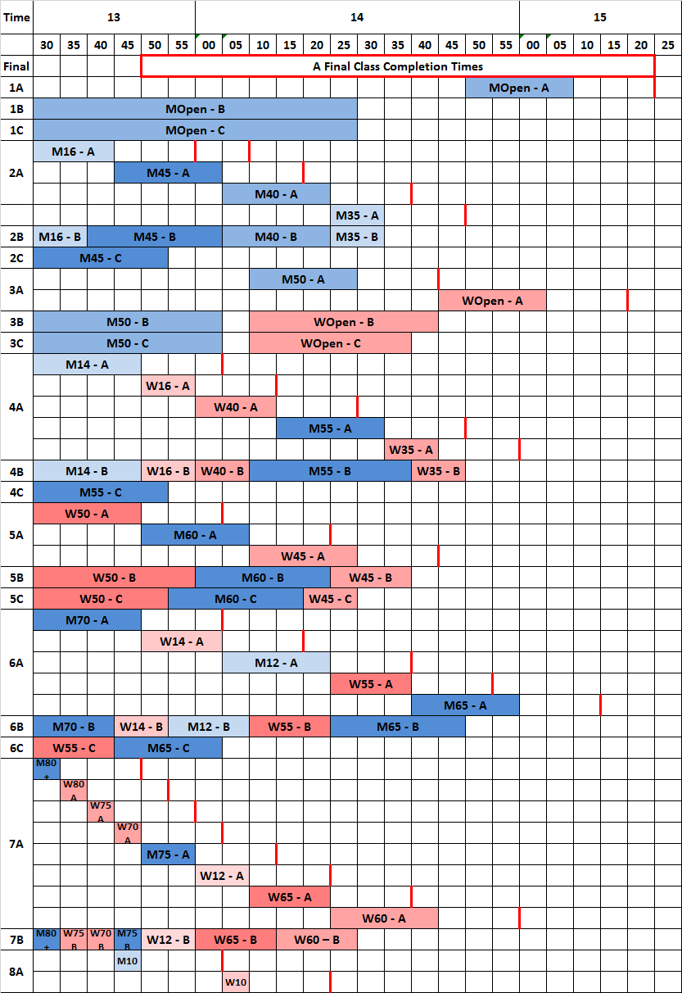Start Time ranges for the Finals, and thus the last starters’ finishing times for each A Final, are expected to be approximately as shown on this table:

**Finishes and Map Reclaim**

Map reclaim for **both** the Heats and the Finals will take place after the last starter of the Finals. This will be from the Event Centre. Club map bags will be issued to one representative from a club. Maps will not be issued on an individual basis from a club bag.

**Heats Finish** is in the Event Arena. On finishing, competitors are to place their maps in named club bags, unless they have had to use a pin punch, or have a particular dispute, in which case this is to be declared to Finish Officials.  These maps will be sealed in an envelope to be taken by the competitor to Download. All finishers are to proceed promptly to Download via the clearly signed route. Download will close at 12:05.

**The Finals Finish** is in the Event Arena. Please go straight to Download, via the clearly signed route. Maps will be collected in the named club bags as above. After the last Open A Final competitors have started (c.15:00) maps will not be collected.

**Results**

Once you have successfully downloaded in the Event Centre please move away from the Download area to avoid congestion. Results will be displayed by the Event Centre and will also be available online at the British Sprints website as soon as possible after the event at [www.britishsprintchamps.org.uk/page/results](http://www.britishsprintchamps.org.uk/page/results)

Intermediate results should be available on Event Arena WiFi "liveo" (<http://results> or <http://liveo>) and, mobile communications permitting, at [www.live-o.org](http://www.live-o.org).

**Radio and Spectator Controls**

**Heats:**

All Heats of courses 1 (MOpen) and 3 (WOpen and M50) have a radio control at approximately 60% and 70%, respectively, of the way round the courses. Immediately after the radio control competitors from these courses, and Heats courses 2 and 4 (who do not visit the radio control), will be visible from the Event Arena for about 500 metres. There are other spectating opportunities AFTER competitors have completed their races. Note that there are places which are out of bounds to competitors until the completion of the Finals.

**Finals:**

Courses 1A (MOpen A Final) and 3A (WOpen and M50 A Finals), amongst others, visit an intermediate radio control about 60% of the way around. This is followed by a “pre-warning” radio control approximately 300 metres from the Finish. The only spectator opportunity for the Finals (before the completion of your run) will be from the west-most orienteering trader site (see site map) and that is after the “pre-warning” control. Competitors who have not yet raced their Final should be careful not to go beyond the out-of-bounds notices or you may be disqualified.

**Prize Giving**

This will take place in the Event Arena, or in the event of inclement weather at the Event Centre, as soon as possible after the Finals finish; approximately 16:00. It is hoped that as many of you as possible will attend the presentation of prizes. These will be presented by:

Judith Holt, British Orienteering Chair

Simon Greenwood, SEOA Chair

Keith Marsden, SEOA Junior Squad Lead Coach

**Officials & Clubs**

|  |  |  |
| --- | --- | --- |
| Organiser: | Tim Pribul | CHIG |
| Planners: | Mike Elliot | MV |
|  | Andy Robinson | SLOW |
|  | Tom Edelsten | CHIG |
| Controller: | Steve McKinley | SN |
| Race Day Organiser | Ray Curtis | CHIG |
| Download & Results: | Michael Napier (MERCS) | NOC |
| Jurors  Reserve Jurors: | Chris Burden  Colin Duckworth  Andy Yeates  Richard Payne  Adrian Barnes | AIRE  TVOC  WCH  EPOC  NATO |

**Acknowledgements and thanks:**

We are very grateful to the following for their help and for enabling us to stage this event at

Queen Elizabeth Olympic Park:

London Legacy Development Corporation

East Village

Lea Valley Regional Park

Taylor Wimpey

Lendlease

Timber Lodge - Unity Kitchen Café and Events

Members of CHIG, HH, LOK, DFOK, SAX, HAVOC, SLOW, MV, SOS

LLDC Park Champions

Members of Woodford Green Athletic Club with Essex Ladies

[Taylor Wimpey logo](https://www.taylorwimpey.co.uk/)